BDA Assignment-3
Q1) Describe the characteristics of Apache Spark.
A)
Apache Spark is one of the most powerful open-source frameworks for big data processing and analytics. It was developed at UC Berkeley’s AMPLab and later donated to the Apache Software Foundation.
Characteristics of Apache Spark:
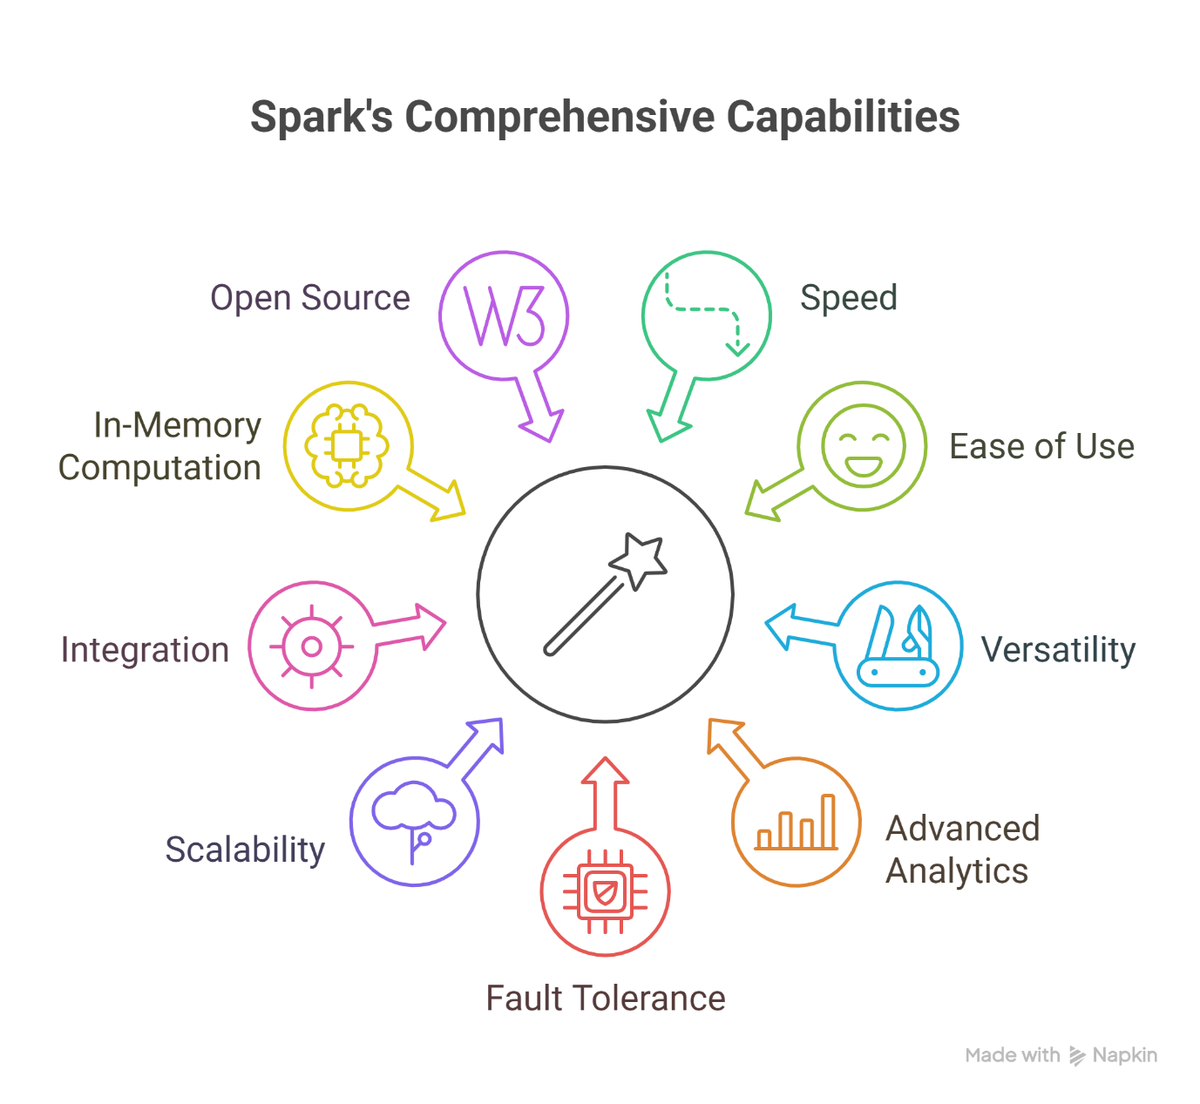
1. Speed
- Spark is designed to process large amounts of data very quickly.
- Unlike Hadoop MapReduce, which writes intermediate results to disk after each step, Spark keeps most computations in memory (RAM).
- This reduces disk read/write operations, making Spark up to 100x faster for in-memory processing and 10x faster for on-disk processing.

2. Ease of Use
- Spark supports multiple popular programming languages: Java, Scala, Python, R, and SQL.
- It comes with built-in APIs that allow developers and data scientists to easily write applications.
- Example: You can perform something complex like machine learning with just a few lines of Spark code.

3. Versatility (Multi-Purpose Framework)
- Spark is not just for batch processing like Hadoop; it supports:
  - Batch Processing (handling stored data in bulk)
  - Real-time Stream Processing (data as it comes in, e.g., live tweets or sensor feeds)
  - Interactive Queries (using Spark SQL)
  - Machine Learning (via MLlib)
  - Graph Processing (via GraphX)
- This makes it a one-stop solution for many big data scenarios.

4. Advanced Analytics
- Spark goes beyond simple data processing. It can handle:
  - SQL queries
  - Machine learning algorithms
  - Graph computations
  - Streaming analytics
- Instead of using different tools for different tasks, Spark gives you everything in one unified framework.

5. Fault Tolerance
- Spark automatically handles failures.
- It keeps track of the "lineage" (history) of transformations on the data. If something fails, Spark can recompute lost data using this lineage information.
- This makes it reliable for running large-scale jobs.

6. Scalability
- Spark can run on a single machine, a cluster of machines, or even in the cloud.
- It works with thousands of nodes and petabytes of data.
- This scalability makes it useful for both small startups and big enterprises.

7. Integration with Big Data Ecosystem
- Spark plays nicely with other big data tools.
- It can run on top of Hadoop YARN, Apache Mesos, Kubernetes, or its own standalone cluster manager.
- It can access data from HDFS, Cassandra, HBase, Amazon S3, and many other sources.

8. In-Memory Computation
- Spark’s key advantage is in-memory computing.
- Data is cached in memory (RAM) during processing, so repeated operations on the same dataset are extremely fast.
- This is especially useful in iterative algorithms like those used in machine learning.

9. Open Source and Community Driven
- Spark is an open-source project with a huge community of developers and contributors.
- It keeps evolving quickly with frequent updates, bug fixes, and new features.

Q2) Illustrate how Apache Spark works with a simple workflow.
A)
Apache Spark works on a cluster computing model where data is processed across multiple machines.
Step-by-Step Workflow:
1. Data Input
- You start by giving Spark some data.
- This data can come from HDFS (Hadoop Distributed File System), S3, Cassandra, local files, or any database.
- Example: You want to analyze a large log file stored in HDFS.

2. Spark Context / SparkSession
- Spark applications always begin with creating a SparkSession (the entry point to Spark).
- Think of this as your connection to the Spark cluster.
- It tells Spark how to access the cluster and where your data is located.

3. Loading Data into RDD/DataFrame
- Once SparkSession is created, data is loaded into an RDD (Resilient Distributed Dataset) or DataFrame.
- RDD = The fundamental data structure of Spark. It represents a distributed collection of objects spread across the cluster.
- DataFrame = A higher-level abstraction (like an Excel sheet or SQL table).
Example (PySpark):
from pyspark.sql import SparkSession

spark = SparkSession.builder.appName("Example").getOrCreate()
data = spark.read.text("hdfs://path/to/logfile.txt")

4. Transformations (Defining the Logic)
- You apply a series of transformations (like map, filter, groupBy, select).
- These transformations don’t run immediately. Instead, Spark builds a logical plan (a DAG – Directed Acyclic Graph).
- This DAG represents the steps Spark will take to process the data.
Example:
filtered_data = data.filter(data.value.contains("ERROR"))
(Here we’re filtering only the lines that contain “ERROR” in the log file.)

5. Actions (Triggering Execution)
- Spark runs transformations only when you call an action like count(), collect(), show(), or save().
- Actions trigger Spark to actually execute the plan it has built.
Example:
error_count = filtered_data.count()
print("Number of errors:", error_count)

6. Job → Stages → Tasks
- When an action is triggered, Spark’s Driver Program breaks the job into smaller units:
  - Job: The whole execution request (e.g., “count the errors”).
  - Stages: Logical phases in the job, separated by data shuffle points.
  - Tasks: Smallest unit of work, assigned to individual worker nodes.
- The Cluster Manager (like YARN, Mesos, Kubernetes, or Spark’s own) distributes tasks to executors (workers).

7. Parallel Execution
- Each Executor (Worker Node) processes its share of the data in parallel.
- Results are stored in memory (or disk if needed).
- Spark ensures fault tolerance: if one node fails, the task is rerun on another node using lineage info.

8. Result Collection
- Once all tasks finish, the results are collected back to the Driver Program.
- You can display them, save them to a file system, or push them into a database.
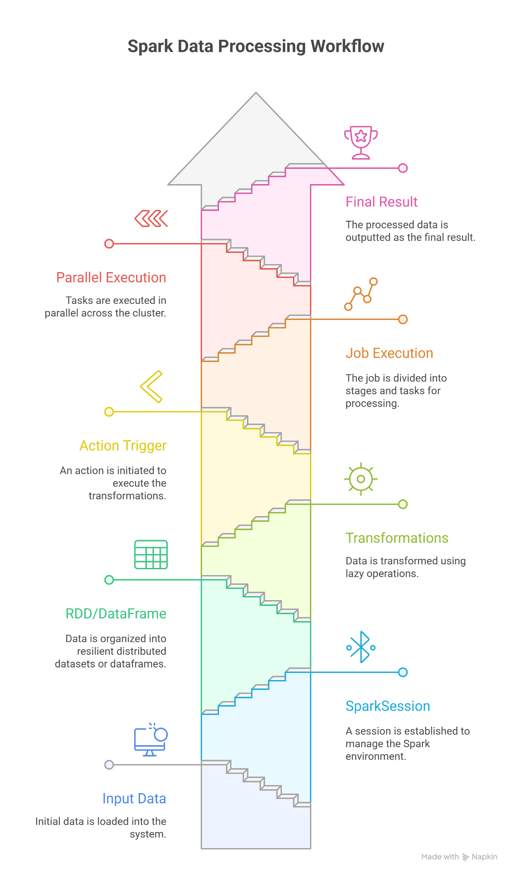

Q3) Differentiate between Hadoop MapReduce and Apache Spark.
A)
Feature | Hadoop MapReduce | Apache Spark
Processing Speed | Slow – writes intermediate results to disk between each step. | Very fast – keeps most data in memory (RAM), reducing disk I/O.
Data Processing Model | Works in batch mode only (processes stored data). | Supports batch + real-time streaming + interactive queries + machine learning.
Ease of Use | Complex – requires writing long Java code for even simple tasks. | Easy – supports Scala, Python, Java, R, and SQL with user-friendly APIs.
Latency | High latency because of continuous disk reads/writes. | Low latency because of in-memory computing.
Iterative Processing (e.g., ML algorithms) | Inefficient – re-reads data from disk for every iteration. | Efficient – keeps data in memory, perfect for machine learning & graph algorithms.
Fault Tolerance | Uses replication (keeps multiple copies of data in HDFS). | Uses RDD lineage to recompute lost data when needed (more efficient).
Resource Management | Runs on YARN (Hadoop cluster manager). | Can run on YARN, Mesos, Kubernetes, or its own standalone manager.
Data Sources | Mostly works with HDFS. | Works with HDFS, HBase, Cassandra, S3, Hive, and many others.
Use Cases | Best for batch processing of very large datasets (e.g., log analysis, ETL). | Best for real-time analytics, machine learning, graph processing, and fast batch jobs.
Learning Curve | Steeper – mostly Java-based, more code required. | Easier – APIs in multiple languages, concise code.
Ecosystem | Part of the Hadoop ecosystem (with HDFS, Hive, Pig, etc.). | Has its own ecosystem (Spark SQL, Spark Streaming, MLlib, GraphX).
Performance | Slower compared to Spark. | Up to 100x faster in-memory, 10x faster on disk.
Maturity | Older and more stable (since 2005). | Newer (since 2014), but rapidly growing and widely adopted.

Q4) Evaluate the role of Apache Spark as a unified analytics engine.
A)
Apache Spark is widely known as a unified analytics engine because it brings together different types of data processing tasks under one single framework, instead of requiring separate tools for each type of workload.

1. Batch Processing
- Traditional big data tools like Hadoop MapReduce were mainly designed for batch jobs (processing large stored datasets).
- Spark supports batch processing too, but with the advantage of in-memory computing, making it much faster.
- Example: Processing a large set of transaction logs at the end of the day.

2. Real-time Stream Processing
- A big limitation of Hadoop MapReduce is that it cannot handle real-time data streams.
- Spark introduces Spark Streaming (and now Structured Streaming) to process live data as it arrives (e.g., Twitter feeds, IoT sensor data, stock prices).
- This makes Spark powerful for use cases where businesses need instant insights instead of waiting for batch jobs.

3. Interactive Querying with SQL
- Spark has Spark SQL, which allows users to query structured and semi-structured data using familiar SQL queries.
- It integrates with business intelligence (BI) tools and allows data analysts (who may not know programming) to run interactive queries on big data.
- Example: A company analyst querying millions of sales records with a simple SELECT statement.
4. Machine Learning
- Instead of using a separate system for ML, Spark includes MLlib, a library with algorithms for classification, regression, clustering, recommendation, etc.
- Because Spark stores data in memory, it’s very efficient for iterative algorithms used in machine learning (like training models).
- Example: Building a recommendation system for e-commerce users directly in Spark.

5. Graph Processing
- Spark includes GraphX, a library for graph computation.
- It allows analysis of data with complex relationships, such as social networks, fraud detection, or supply chain optimization.
- Example: Finding influential users in a social media network.

6. Unified Data Sources
- Spark can connect to many data sources: HDFS, Cassandra, HBase, Hive, Amazon S3, JDBC databases, and more.
- This means the same engine can be used to process all types of data: structured, semi-structured, and unstructured.

7. Single API for Multiple Workloads
- Developers can use the same Spark APIs (in Python, Scala, Java, R, or SQL) for different types of workloads.
- This reduces the need to learn and maintain multiple tools (e.g., one for SQL, one for streaming, another for ML).

8. Scalability and Flexibility
- Spark can run on a single laptop, on a cluster of thousands of machines, or in the cloud.
- Its ability to handle both small-scale and large-scale data makes it versatile for all kinds of organizations.

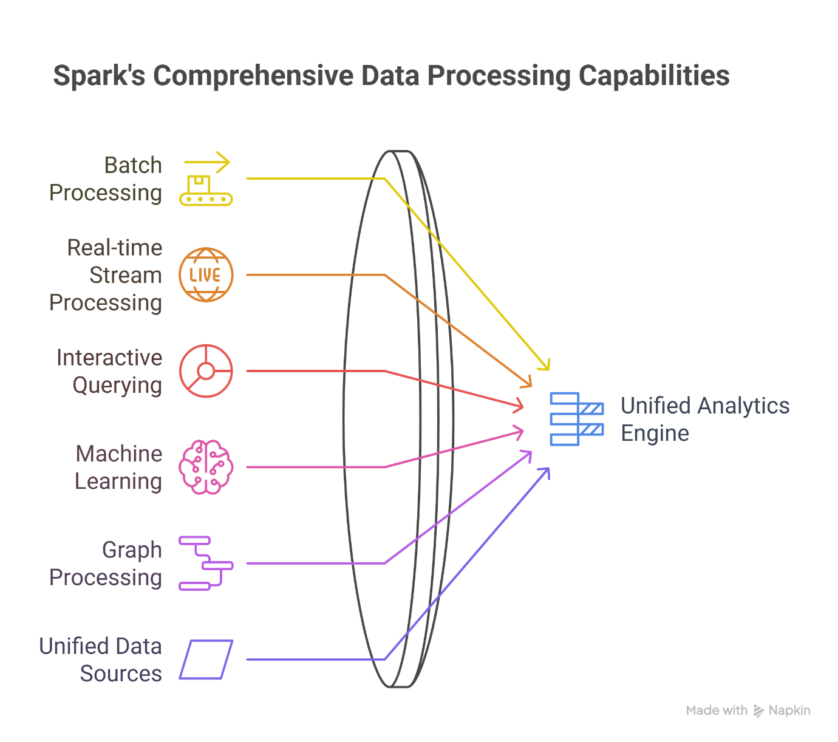

Q5) Design a real-time use case where Spark can be used effectively.
A)
Real-Time Use Case of Apache Spark: Fraud Detection in Online Transactions
Imagine a large e-commerce company (like Flipkart or Amazon) or a banking system that processes millions of transactions every day.
- Some of these transactions may be fraudulent (e.g., stolen credit cards, fake accounts, abnormal purchase patterns).
- The system needs to detect fraud in real-time and take immediate action (like blocking the transaction or alerting the customer).

Traditional systems like Hadoop MapReduce can process stored transaction data at the end of the day (batch processing), but that’s too late — the fraud has already happened.
Apache Spark, with its Structured Streaming and MLlib (Machine Learning library), is perfect for this use case because it can:
- Process real-time transaction streams (as they occur).
- Compare transaction patterns with historical data.
- Use machine learning models to predict fraud instantly.
- Trigger alerts or block suspicious transactions in seconds.

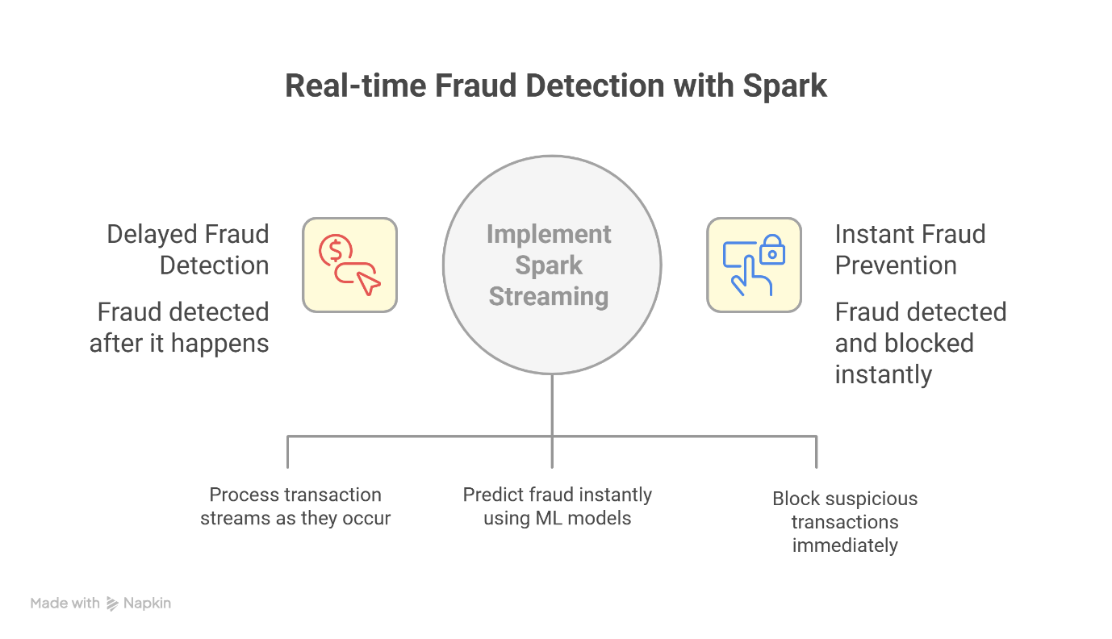

1. Data Sources
- Live transaction data is continuously generated from:
  - Credit/debit card swipes
  - Online banking apps
  - Mobile wallets (e.g., Paytm, Google Pay)
- This data flows in real-time from systems like Kafka, Flume, or Kinesis into Spark.

2. Stream Processing with Spark
- Spark Streaming ingests these transaction streams.
- Each transaction is checked for:
  - Unusual transaction amount (e.g., ₹2,00,000 spent suddenly on a new device).
  - Unfamiliar location (e.g., login from Delhi, but card was used in London 5 minutes later).
  - Frequency of transactions (e.g., multiple failed login attempts).

3. Machine Learning with MLlib
- Spark MLlib is used to train a fraud detection model based on past transaction data.
- Features considered:
  - Average spending amount
  - Time of purchase (day/night)
  - Device used (mobile, desktop)
  - Transaction location
- When a new transaction comes in, Spark applies the ML model to decide if it’s fraudulent or legitimate.

4. Real-time Actions
- If the transaction is flagged as fraudulent:
  - Spark immediately sends an alert to the fraud monitoring team.
  - The system can block the transaction automatically.
  - The customer can be notified instantly (via SMS/email).
- If the transaction is safe, it is approved without delay.

5. Storage and Analytics
- All transactions (fraudulent + safe) are stored in HDFS or a cloud storage system (like Amazon S3) for further analysis.
- Spark SQL can be used later for reports, dashboards, and deeper analysis of fraud patterns.

Benefits of Using Spark in This Case
- Speed – Detects fraud within seconds using in-memory processing.
- Scalability – Can handle millions of transactions per second in real time.
- Unified Framework – Same engine handles streaming + machine learning + batch analytics.
- Cost Efficiency – Prevents fraud losses by blocking suspicious activity immediately.

Q6) Summarize the importance of Spark in large-scale data analytics
A)
Importance of Apache Spark in Large-Scale Data Analytics
In today’s digital world, businesses, governments, and organizations generate massive volumes of data every second — from social media, sensors, financial transactions, healthcare systems, e-commerce, and more.
To make sense of this data and extract insights, we need tools that are fast, scalable, reliable, and versatile.
Apache Spark plays a key role in this domain because it provides exactly that.
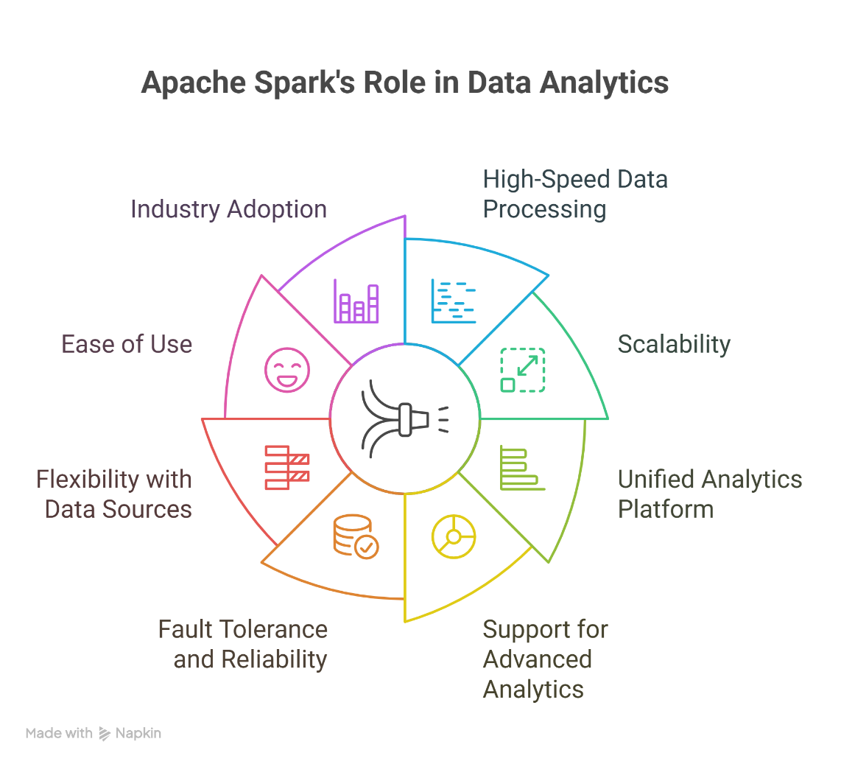

1. High-Speed Data Processing
- Spark’s in-memory computing allows it to process data up to 100x faster than traditional systems like Hadoop MapReduce.
- This speed is critical when dealing with large datasets where slow processing would delay decisions.
- Example: Analyzing billions of customer interactions in near real-time.

2. Scalability
- Spark can run on a single laptop for small data, but it can also scale to thousands of nodes in a cluster for petabytes of data.
- This flexibility makes it suitable for both startups and global enterprises handling big data at massive scale.
3. Unified Analytics Platform
- Instead of using multiple separate tools, Spark integrates everything into one ecosystem:
  - Batch Processing (historical data)
  - Real-time Stream Processing (live data)
  - SQL Queries (interactive analysis)
  - Machine Learning (MLlib)
  - Graph Processing (GraphX)
- This saves effort, reduces complexity, and ensures all analytics tasks can be done in one framework.

4. Support for Advanced Analytics
- Spark is not limited to simple queries; it supports complex analytics like:
  - Predictive modeling (machine learning)
  - Recommendation systems
  - Fraud detection
  - Natural Language Processing (NLP)
- This makes it powerful for turning raw data into actionable intelligence.

5. Fault Tolerance and Reliability
- Spark uses RDD lineage to automatically recover lost data during failures.
- This ensures that even with large-scale clusters where failures are common, data analytics can continue without major disruptions.

6. Flexibility with Data Sources
- Spark can read from almost any source: HDFS, Cassandra, HBase, Amazon S3, Hive, JDBC databases, NoSQL systems, and more.
- This ability to handle structured, semi-structured, and unstructured data makes it universally applicable.

7. Ease of Use
- Spark supports multiple programming languages (Scala, Python, Java, R, SQL) and provides high-level APIs.
- This lowers the entry barrier, allowing data scientists, analysts, and developers to all use it effectively.

8. Industry Adoption
- Spark has become the de facto standard in big data analytics because of its versatility and speed.
- It is used by companies like Netflix, Uber, Amazon, eBay, and Airbnb for analytics, recommendation systems, fraud detection, and real-time decision-making.

